Ideation Phase
Define the Problem Statements

Date | 03 August 2026
Team ID | N/A
Project Name | SHOPEZ : E-Commerce Application
Maximum Marks | 2 Marks

Customer Problem Statement Template:
Create a problem statement to understand your customer's point of view. The Customer Problem Statement template helps you focus on what matters to create experiences people will love.
A well-articulated customer problem statement allows you and your team to find the ideal solution for the challenges your customers face. Throughout the process, you’ll also be able to empathize with your customers, which helps you better understand how they perceive your product or service.

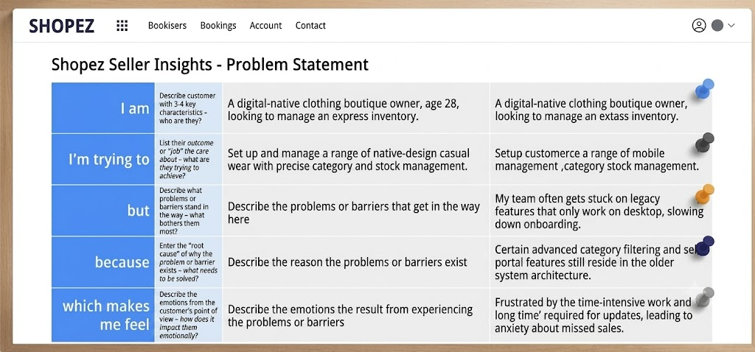

Example:
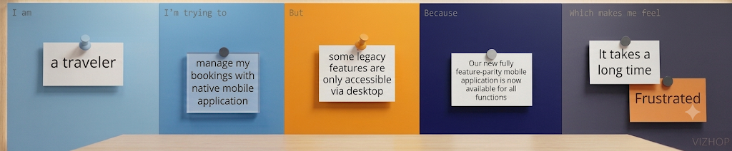
Problem Statement (PS) | I am (Customer) | I’m trying to | But | Because | Which makes me feel
PS-1 | An online shopper looking for a secure and convenient shopping experience. | Browse products, compare prices, add items to my cart, and place orders quickly from anywhere. | Many shopping platforms have complicated navigation, slow performance, and limited product management features. | Existing systems may not provide a simple interface, efficient search, secure authentication, or smooth order management. | Frustrated and less confident about purchasing products online.
PS-2 | A store administrator managing an online shopping platform. | Manage products, categories, customers, and orders efficiently through a single dashboard. | Manual management of products and orders is time-consuming and increases the possibility of errors. | Traditional management methods lack automation, centralized control, and real-time updates. | Overloaded and unable to efficiently manage the online business.

